Benefits of big data evaluation from casthouse machines and BF-probes

Author(s), Name(s) and Affiliations(s)
J.F. Stumper¹, V. Langer², C. Meisch¹, M. Kruessmann¹, M. Moser²,
¹ TMT – Tapping Measuring Technology Sàrl, Luxembourg;
² TMT – Tapping Measuring Technology GmbH, Germany

Contact data
Mark Kruessmann, TMT – Tapping Measuring Technology Sàrl, 32, rue d’Alsace - L-1122 Luxembourg, Luxembourg Tel. +352 261920-2376, e-mail:mark.kruessmann@tmt.com

Mario Moser, TMT – Tapping Measuring Technology GmbH, Hagener Strasse 103, 57072 Siegen, Germany
Tel. +49 271 4014-339, e-mail: mario.moser@tmt.com

Summary
The latest generation of probes and casthouse machines provide a wealth of data that has not been available a few years ago.
The evaluation of this data gives direct feedback to improve the blast furnace efficiency, the equipment maintenance and design and it allows the early detection of critical or deviating process situations.
A stable operation with lower operation and maintenance costs are the final customer benefits.

Key Words
Charging, casthouse, tapping, blast furnace probes, big data

Introduction

Throughout all industries the term “Industry 4.0” has been a major subject in recent years. While the term is often linked to automation and manufacturing industries, it is undisputed that the massive data exchange and the possibilities it provides will affect virtually all industrial sectors.

Even though also blast furnaces are operated with sophisticated expert-systems that rely on multiple process data since many years, new information and communication technologies will push the boundaries not only of what is done today but also to what sort of equipment it will be applied. Targets of newly developed digital solutions can be manifold.

Blast furnace probes are predestined to contribute to a big data approach. While gathering more process relevant data like gas temperatures, pressures, burden profiles or gas compositions can contribute to an even better process understanding and help increasing the process efficiency, also the early detection of process phenomena like burden hangers is strived for to avoid unintentional disruptions.

Digital solutions are also affecting the tapping equipment which is crucial to manage a blast furnace with high level performance.
The quest for more process parameters, the reduction of operational costs and striving towards highest operational reliability also pushes the development of new technologies around clay guns and taphole drills.

This paper provides an overview of the extensive changes that already took place in recent years and gives an outlook what changes will be implemented in the near future.

The reader will be informed,
- How data acquisition of BF-process parameters has changed and which new probe technologies are replacing the conventional designs of the past to provide the multitude of data required

- How these new probe types, respectively their measurement data are already affecting the work of the BF-operators and support them by providing not only multiple data but also a visualization that allows an easier interpretation of the BF process

- How condition monitoring of casthouse equipment (mainly clay guns and taphole drills) will improve their reliability and ease maintenance

- How data acquisition of process parameters enhances the understanding of the tapping process and allows to assess the condition of the taphole

The described measures can be gradually integrated into existing installations with incremental benefits for operations and maintenance.

Overview of today’s BF probes

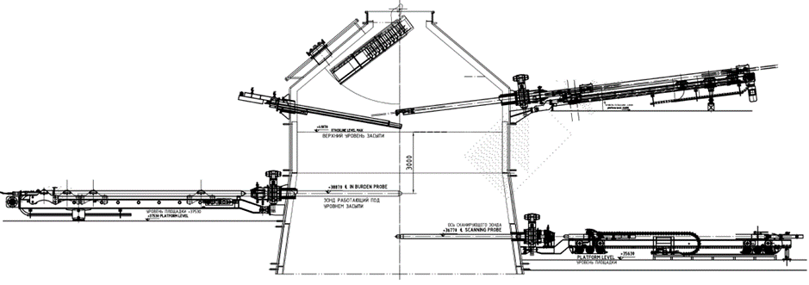

Figure 1: Conventional process instrumentation as still built in the 2010 years.
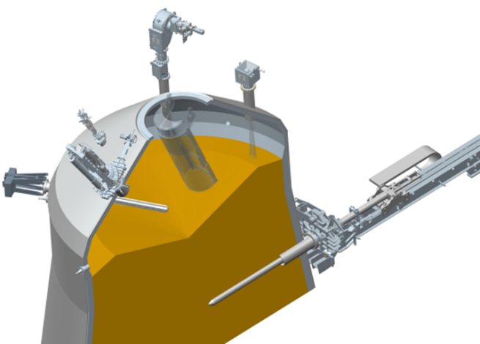

Figure 2: Today’s process instrumentation considers the need for more data acquisition and the requirement for reduced maintenance.

The diversity of blast furnace probes has already been presented extensively in the literature [1, 2]. However, in the last few years, the measurement capability has increased significantly. This becomes clear when comparing the figures of a conventional BF to the modern counterpart. More data can be harvested today with less effort in terms of maintenance.

The traditional lance-based measurement devices (Profilemeter, Above-burden probes) have been replaced by more performant and less mechanical systems such as the 3D-TopScan for the continuous surface measurement [3] and the continuous gas temperature mapping TMT-SOMA [4]. These systems are not limited to one radial measurement but capture the process across the whole BF burden surface in 2D and 3D.

The missing element is the gas analysis, for which in-burden probes are still state of the art. However, the generation change is only one step away with the TMT 90mm-movable-ABT. This is an above-burden probe and comes with a reduced lance diameter, both features inheriting a drastically reduced maintenance effort. It is able to sample gases at 6 to 8 measuring points simultaneously. A complete gas distribution profile is sampled within less than three minutes, such that the charging cycle is quasi not affected.

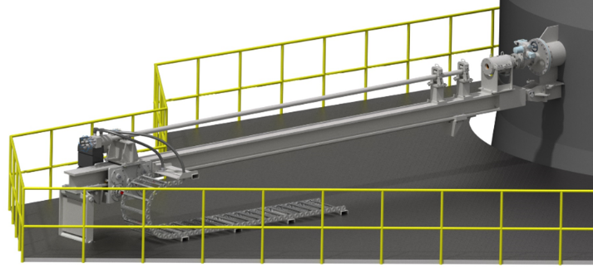
Figure 3: TMT ABP90, the movable lance with simultaneous sampling of gas from 6-8 different positions for fast gas profiling.

Continuous video monitoring is available with a Furnoscope with the LWIR bolometer cameras, which provide images at a higher availability than the preceding NIR systems. However, this device has to be considered as monitoring tool rather than process data harvester, as it cannot provide measurement data in the required accuracy or availability due to the dust and humidity content of the BF atmosphere, and the optical nature of the signal.

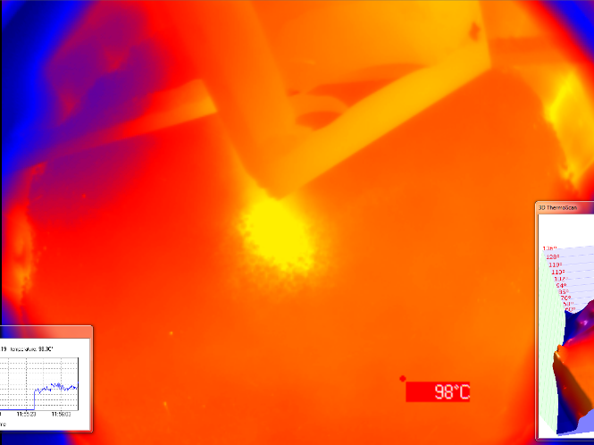
Figure 4: Furnoscope LWIR indicating a worn-out stone box on a BLT chute.

Control Centre – Integrated HMI for all TMT probes

The dynamics and the update rate of the modern probes create one major problem to the user: The sheer amount of data is overwhelming operators and their wish is an inspection tool to understand process events at a single glance. The “TMT control centre” combines the quick-view screens of the individual probes with their many data processing features. Temperature profiles are overlaid with their synchronized burden profile, and the last quarter hour is visualized with the powerful ISO12 and layer models.

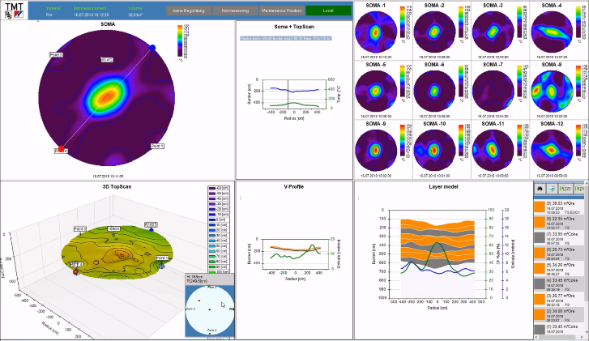
Figure 5: TMT control centre

Interfacing the data

The established industry platform for the blast furnace automation area is SQL-based. TMT probes apply the same philosophy and so are easily integrated in existing Level 2-systems.

To account for the special requirements of probes, TMT probes have a system to store the data in asynchronous format in order to properly match external process data, such as charging data, with the actual measurement data.

Learnings from the data correlation

The blast furnace is a counter current reactor with descending burden and ascending process gas. Already from an independent data analysis of the burdening or the temperature, these modern probes provide more insight than their respective predecessors. Correlating their data provides even more insight than the evaluation of this data independently. Thus, by a supervision of the burden (input) and the gas temperature distribution (output) much can be learned about the internal BF process.

For conciseness and due to the limited scope of this paper, some data is illustrated for one specific scope. The coke push effect is one of the most interesting phenomena in BF control, and until now, the sole means of measurement have been quite complex (e.g. TMT Scanning probe). The same information can today be gathered from a correlation analysis of the modern BF probes.

Coke push effect: If iron-bearing materials are charged on coke, due to the impact forces and the density difference, the burden is moved in a way that was not predicted by the charging. This phenomenon can be observed from the stepwise observation of the layer build-up [3]. However, an additional fact is that if material is appearing from the outside, a temperature drop is observed, but if coke push effect appears, the temperature drops significantly less.

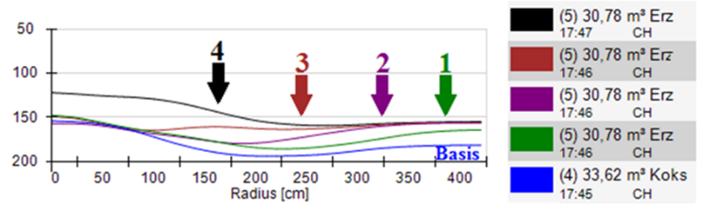
Figure 6: Individual 3D-TopScan analysis reveals the coke push effect.
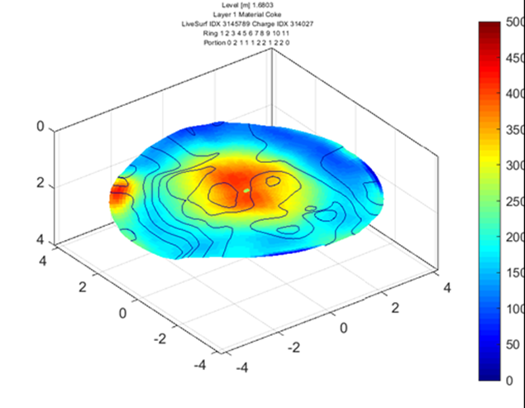
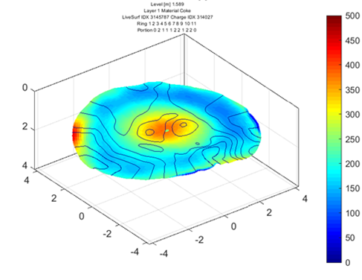
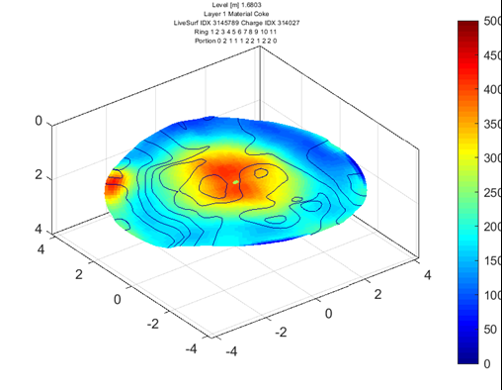
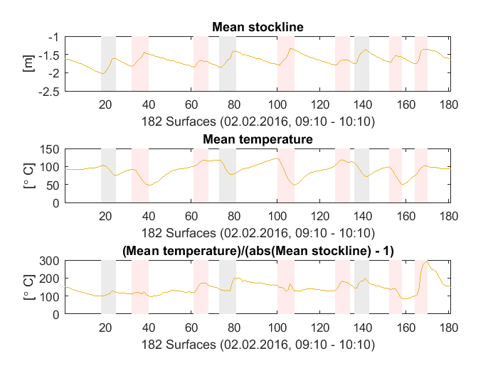
Figures 7 and 8: 4D-Representation: burden surface of the 3D-TopScan and the colours represent the SOMA gas temperature measurement. Top: before charging, Bottom: after charging of a sinter layer. Even though the burden level in the centre has increased, the temperature has not dropped accordingly, which confirms the fact that the centre is pushed coke whereas the wall region was covered with sinter.
Figure 9: This comparison analyses the burden rise and the corresponding temperature drop. The red and grey columns indicate charging of sinter or coke, respectively. It is thus possible to indicate and to quantify the coke push effect by comparing temperature and stockline.

Benefits of big data evaluation from cast house machines
The breakthrough of hydraulic components on modern cast house equipment came along with a substantial increase of installed transmitters. Besides making the machine operation transparent for remote observers, these transmitter signals provide valuable insights into the tapping process and into the condition of the cast house equipment [5].
What is today’s state-of-the-art?
Hydraulic cast house equipment is typically PLC controlled. The main tapping equipment parameters are mostly recorded outside of the PLC, be it on a separate data logging PC or be it within the customers’ Level 2-system. This situation corresponds to the first step of TMT’s concept of a tapping process and equipment condition monitoring system:
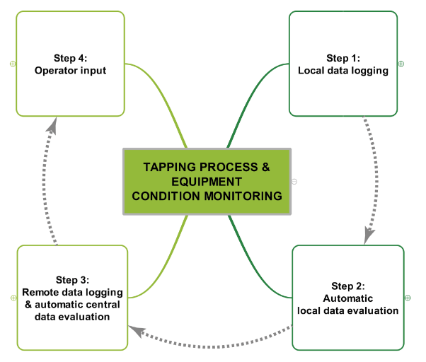
Figure 10: 4-step TMT Condition Monitoring System
Step 1: consists of locally logging TMT tapping equipment data. TMT installed already multiple PC based local data logging systems at customers’ premises.
As a customer benefit historical data can support local troubleshooting of the casthouse equipment.
Step 2: consists of the evaluation of the logged equipment data, to a much greater extent as this is typically done in a PLC.
Step 3: comprises the central data logging and evaluation by TMT.
Step 4: finally adds customer data input into TMT’s tapping equipment condition monitoring and process control system.

TMT is currently implementing a tapping equipment condition monitoring and process control system including steps 2, 3 and 4 in collaboration with a German steel producer.
The analysis of the large amount of cast house machinery data provides statistical information like run-time or duty cycle. This gives a precise overview of the actual level of usage of the equipment.
A second relevant information type concerns process data. While some data like the number of casts per day, the time between two casts, etc. can be tracked by other methods, process data like the actual length of the taphole or the actual clay volume being injected provide a new level of information to the operator. For example, the operator will get advice on the optimum amount of clay to be injected and this optimum amount can directly be applied using the equipment in automatic mode.
Long term performance monitoring is an important part of data analysis. Even a slight deviation indicating a first trend of decreasing equipment performance is tracked and flagged up by the system. This triggers maintenance in time before the situation can become critical.
Comparing performance data between machines at different tap holes, different blast furnaces or different production sites can either detect local improvement potential or confirm the competitiveness of the individual operation. Benchmarking is a precious tool for optimizing equipment performance.
Troubleshooting capacity is now no longer limited to the personnel on site. OEM supplier experts can provide remote support via secured data transfer between the equipment manufacturer and the plant. This can shorten downtimes considerably and hence decrease the operation costs.
Maintenance recommendations in time are amongst the most valuable results of tapping equipment data analysis. Failures should not occur surprisingly but can be avoided by maintaining, reworking or exchanging parts in time - not too late but also not too early. Even better, the maintenance occurrence will match the planned equipment downtime. Reducing machinery downtime and decreasing the local spare parts stock will significantly contribute to more cost-efficient operation.
For data analysis, algorithms based on the manufacturer’s experience are applied as a “white box” approach to derive target information from the vast data pool. These algorithms will be complemented by a “black box” approach, using artificial intelligence (AI)-based tools for signal analysis. Machine learning techniques will automatically improve the tools while they are applied and so enhance the overall performance of the analytics over time.

A: Tapping equipment condition monitoring and maintenance optimization

To predict equipment service life, it is important to monitor the operation time of main components.
The example below shows the hydraulic main pump motor actuations for one day:

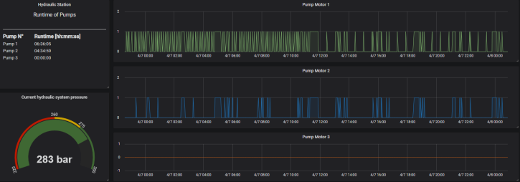
Figure 11: Monitoring of hydraulic main pumps and pressure
The change of the actuation frequency of the main pump motor 1 on 07.04.2019 can be clearly identified.
With the hammer and the rotation motor being key components of hydraulic tap hole openers, it is crucial to monitor their operation. The dashboard below does not only give a quick overview on the statistics of use of these components but also provides information about the performance of the drilling operation itself during a 17 hours period of blast furnace operation:

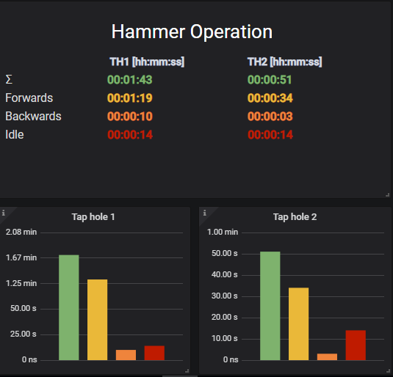
Figure 12: Operation modes of hammer of tap hole opener
A high ‘drilling without hammer’ quota of the ‘total drilling time’ shows that the use of the hammer is limited to the hardest part of the tap hole. These parameters need to be closely monitored together with the ‘total drilling time’ of the tap hole opening as the latter has to be kept within acceptable limits for a reliable and safe blast furnace operation.
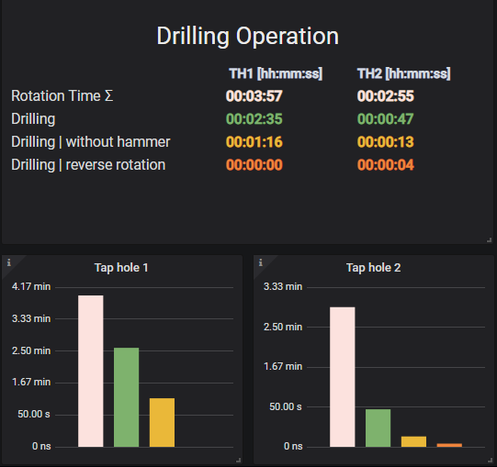
Figure 13: Operation modes of drilling of tap hole opener
B: Process monitoring
The tap hole length is an important tapping process parameter. To avoid damaging the hearth refractory, there is a minimum tap hole length that should not be underrun. The injected clay volume can be used to antagonize an excessive shortening of the tap hole. Here is an example of the evolution of the tap hole length marked in yellow where the corresponding injected clay volume is indicated in light blue:
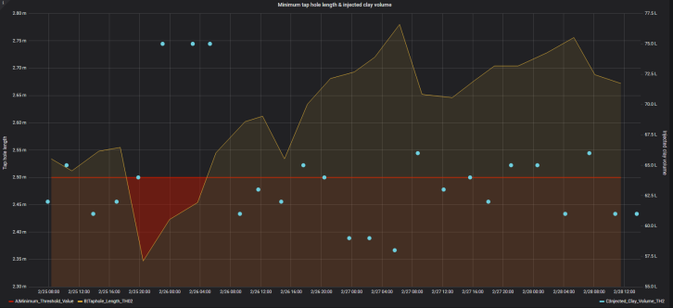
Figure 14: Monitoring of tap hole length and clay volume injected
The red zone indicates a tap hole length below the minimum threshold value which led to a corrective increase of the injected clay volume. The larger amount of injected clay was applied until the tap hole length exceeded again the minimum threshold value. This is part of the intelligence of a modern tapping process monitoring and optimization system.
The automatic tap hole open detection provides amongst others the precise timestamp of the tap hole opening. Here is an example of alternate tapping operation on a two tap holes blast furnace:
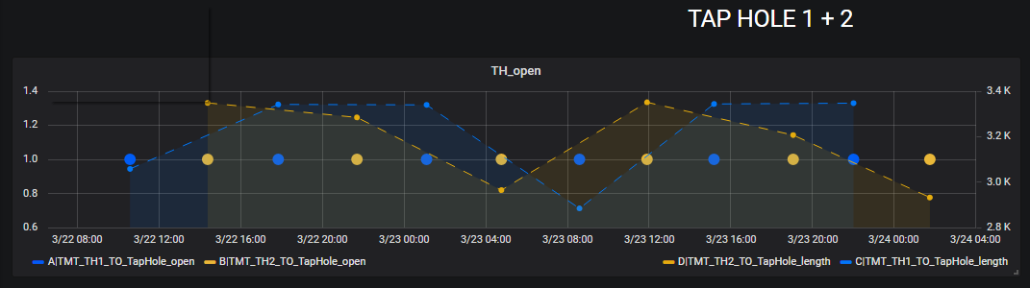
Figure 15: Tap hole detection and measurement
This graph shows a typical drilling operation with limited hammer use:
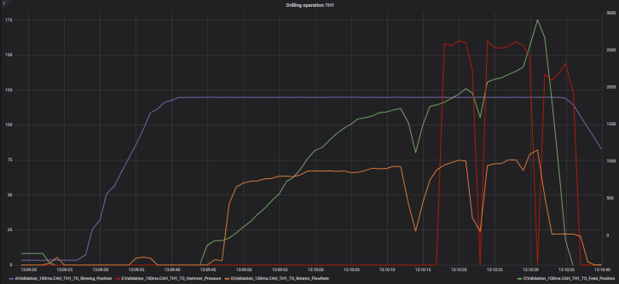
Figure 16: Analysis of tap hole opening process
The red curve above shows the hammer pressure evolution. The drilling speed increase due to the hammer actuation in the hardest part of the tap hole channel corresponds to the slope augmentation of the green carriage position curve at 13:10:17 on the time axis. The carriage has been moved backwards twice to enhance the evacuation of the drilled material [6].
The reverse hammering function was activated to guarantee fast carriage retraction after opening the tap hole. This protects the tap hole opener against excessive hot metal splashing in the working position at the tap hole.
The tapping equipment condition monitoring system allows the definition of “best practice tap hole openings”. The pattern recognition feature then provides automatic evaluation of the drilling operations. This feed-back can be used for optimising both manual operation as well as PLC control of the tapping equipment.

Conclusion

Industry 4.0 will sustainably change the way blast furnaces and their key equipment will be operated in the future. The diversity of possibilities will grow with the variety of available data.
This paper describes a first approach to the topic that is geared to increase efficiency of the blast furnace, to increase availability of the critical equipment and ease its maintenance.
As for most of the other industries, all steps are ultimately geared to reduce costs and increase process efficiency to give the BF operators a competitive edge in a demanding market.

Abbreviations

AI Artificial Intelligence
BF Blast Furnace
BLT Bell Less Top
CMS Condition Monitoring System
HMI Human Machine Interface
LWIR Long Wave Infra-Red
NIR Near Infra-Red
OEM Original Equipment Manufacturer
PLC Programmable Logic Controller

References
[1] J. van der Stel, K. Andreev, T. Bell, J. Raleigh: Stable blast furnace control by advanced measurement techniques; Metec 2015
[2] J.F. Stumper, M. Krüssman, C. Bodeving, D. Cruz: Blast Furnace Process Improvement with Probes and Measurement Systems; ABM 2014
[3] J.F. Stumper, T. Mirkovic, K. Viktor, T. Josupeit, J. Pethke: Blast Furnace Burden Distribution Analysis based on the “3D TopScan” Profilemeter; AISTech Iron and Steel Technology, 2016
[4] M. Tonteling, M. Brodeck, H. Rausch: 2D Blast Furnace Top Gas Temperature Measurement System — TMT SOMATM; AISTech Iron and Steel Technology, 2013
[5] Dr. S. Weyer, Dr. J.P. Simoes, Y. Reuter, F. Hansen, C. Solver, C. Meisch, A. Schmitz: Digital Solutions for Modern and Efficient Ironmaking; AISTech Iron and Steel Technology, 2019
[6] C. Bodeving, M. Flammang, M. Krüssman, D. Cruz: TMT-BBG HS 600 – Optimization of Taphole Drilling in Economical and Performance Points of View; ABM 2016

